Southern Colonies Guided Notes

The Virginia Company

- An English firm that planned to make ______________ by sending people to America to find
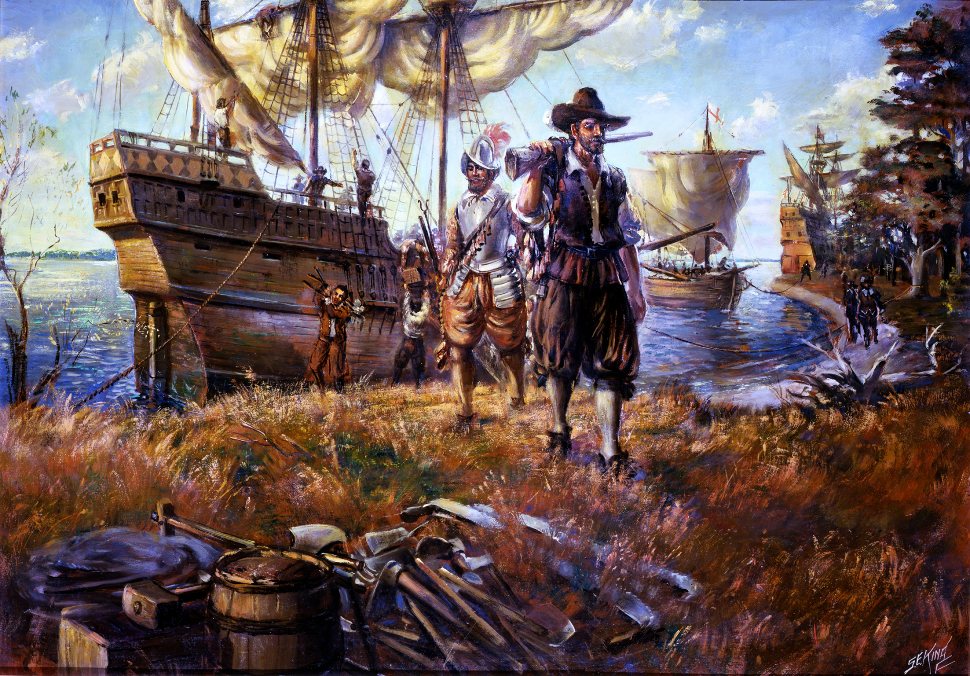
__________ and other resources to send ______________.

House of Burgesses
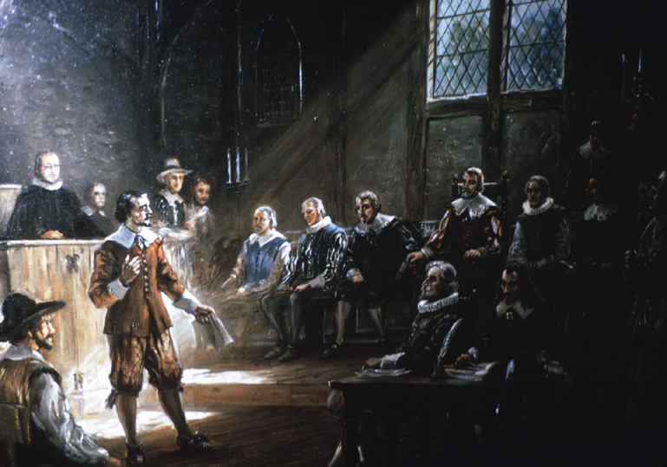
- The first European type of ______________ body in the Colonies, established
by the Virginia Company.
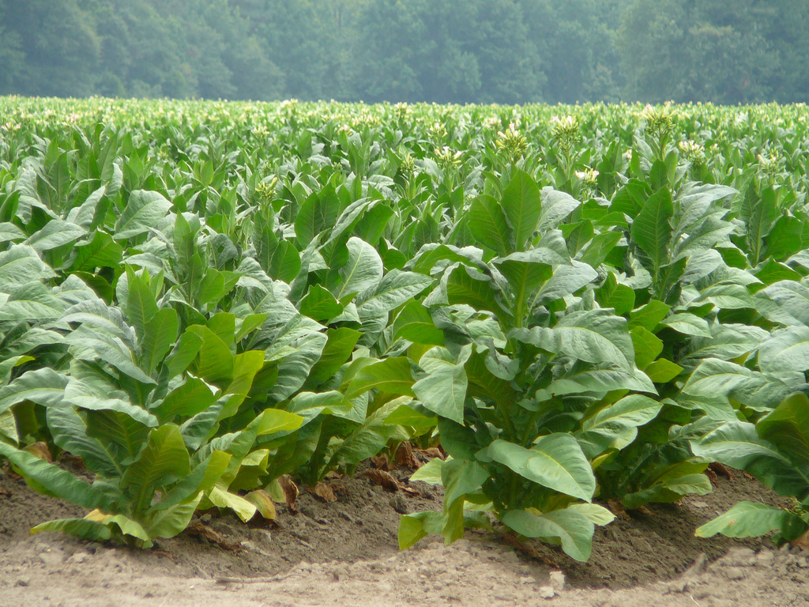

Tobacco

- __________________ became the major cash crop and source of _______________ for the Virginia colony.

- The work to cultivate tobacco was labor intensive, and led to the dependence on _______________.
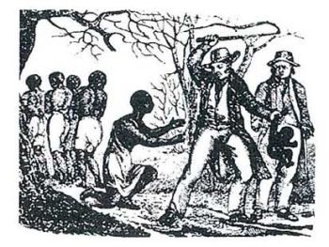

The Virginia colonists’ relations with the Powhatan Indian

- The Powhatan Indians were _________________ to Virginia.
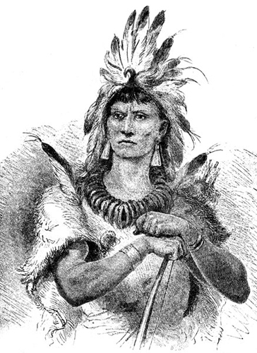

- The colonists forced the Powhatans off their ___________________ to grow _________________.

Bacon’s Rebellion

- The landless rebels staged a rebellion known as _________________________- and uprising against

the governor and his wealthy landowner supporters as an attempt to gain ________________.
