Production Possibilities Curve/Graph

What is it? _______________________________________________________________________________________________________________.

Using resources to maximize production.
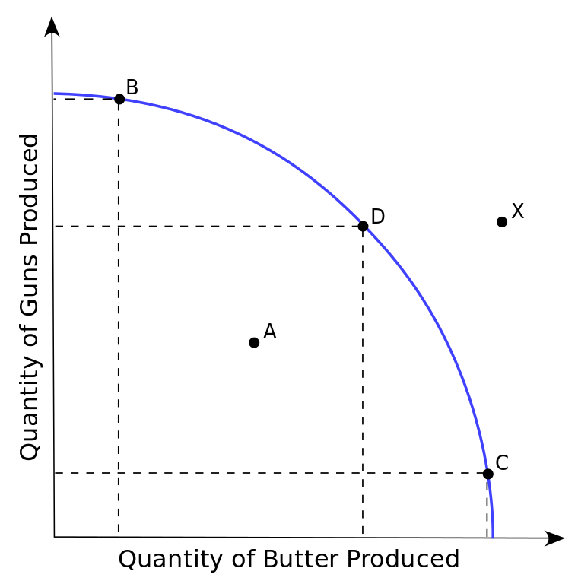

Using fewer resources than an economy is capable of using.

If more land, labor, or capital resources become available.

