A Grand Adventure: Colonial Survival Game

“Cheerio Old Chap!”

You are living in 17th century England. The year is 1614, and King James is granting charters for colonies in the New World. Jamestown, the first successful English colony in America, is thriving under the leadership of men such as John Rolfe and Captain John Smith. While the risks and hardships are considerable, the lure of limitless lands and untold wealth are very tempting. Throughout Great Britain, there is religious turmoil, social unrest, and widespread crime and unemployment. Opportunity beacons across the Atlantic Ocean for anyone daring enough to grab hold.
The Task:
You will set up a colony in the New World which the Spanish are calling America. Furthermore, you will make decisions which will affect the outcome of your colony within this simulation.
But first you must know a few key terms. Write the word next to the definitions below.
Vocabulary:
Charter colony headright
British pound militia indentured servant
Joint-stock company

1. ______________________ a laborer who agreed to work without pay for a certain period of time in exchange for passage to America. Indentured servants were not free until they completed their years of service.
2. ______________________ a business entity owned by shareholders. Each shareholder owns the portion of the company in proportion to his or her % of ownership.
3. ______________________a new settlement or territory established and governed by a country in another land
4. ___________________ the official currency of England.

5. _____________________ a document that gives the holder the right to organize settlements in an area.
6. ____________________ a grant of land, usually 50 acres given to a settler, given by certain colonies and companies in the 17th and 18th centuries
7. ___________________ an army composed of non-professional fighters; citizens that can be called upon to enter a combat situation.

Step 1: Planning your colony
Your colony needs a name! ______________________________________

Circle the purpose of your colony below.
Search for Gold Raise Cash Crops Religious Freedom

Step 2 All Aboard!
How many colonists do you want to take with you?
____________________________

Step 3 Price of Passage
Decide on the Total cost for Passage of the Colonists _________________________________________________.

Step 4 Supplies
Circle your level of provisions below.

Exceptional Supplies Sufficient Supplies Meager Supplies
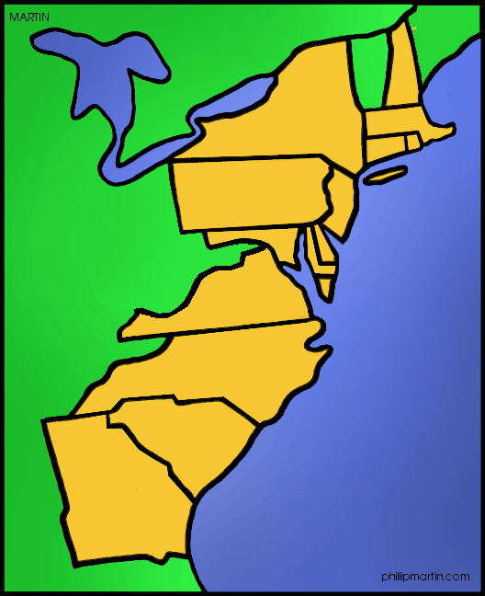
Step 5 Location
Your colony will be at ______ degrees North.

Step 6 Local Inhabitants
Your policy towards the Native Americans will be one of: (Circle below)
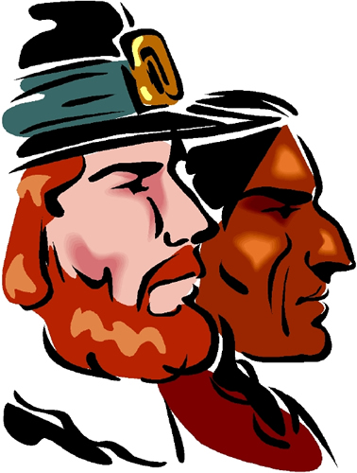

Friendly Cooperation Indifference Aggression

Step 7 Logistics
Part A:
You started your colony to ___________________________. You start with _____________________British Pounds.

Part B:
According to the chart above, how many colonists signed on?

According Step 1, how many colonists did you initially want?

Did enough people show up to go? Yes No

How many colonists are you now actually taking?

*Some steps below may ask you to subtract money from you total balance.
Price of Passage Across the Atlantic
Subtract the Total cost for Passage of the Colonists from your balance ___________________________________.
Your new balance is ____________________.
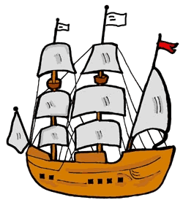

Price of Leasing the Ships
1. How many ships? __________________________.
2. Subtract the total cost of ships from your balance. __________________________________
3. New Balance _______________________.
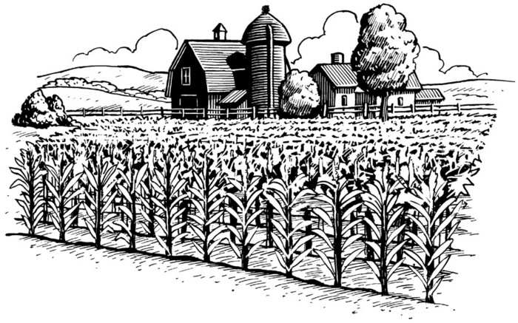
Crop Expense
1. What is your crop expense? ____________________________
2. New Balance _____________________.

Cost of Supplies
1. What is the cost of supplies? __________________________
2. New Balance ______________________________.

Protecting your colony
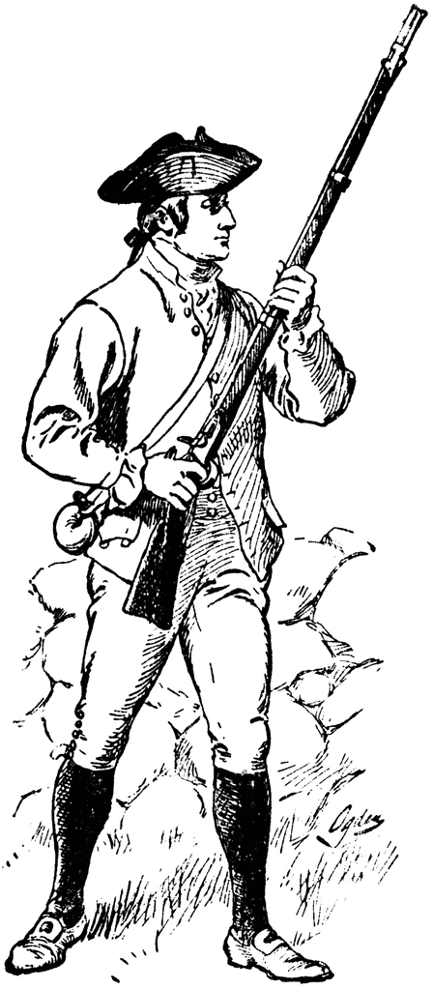
1. Are you going to hire soldiers? Yes or No?
2. New Balance ____________________.

Tradesmen
1. Number of each tradesmen you need for your colony. __________________
Multiply # of each tradesmen by his annual salary. Add all salaries together and subtract total cost of tradesmen from your balance.
2. New balance ______________________.

Reflection
Were you successful? Do you have a positive or negative balance?

If you have a negative balance, where can you cut costs?

What were the most difficult decisions?

How was planning for the voyage important?

